Assignment -4
Task -1
Description: Zero-shot: Prompt AI to write a function that checks whether a given year is a leap year.
Prompt: AI to write a function that checks whether a given year is a leap year.

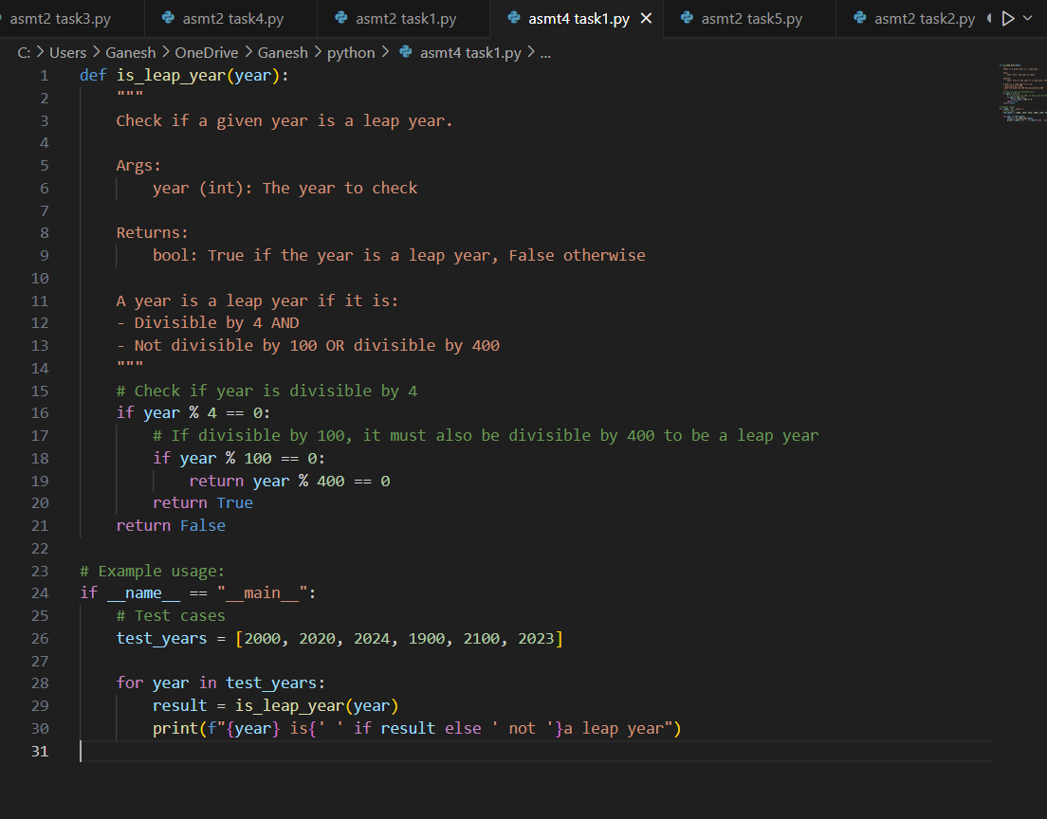

Expected Output: AI-generated function with no examples provided
Practical Output:
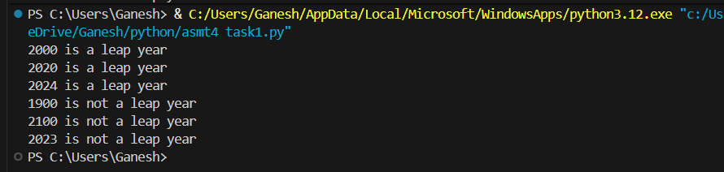
Task -2
Description: One-shot: Give one input-output example to guide AI in writing a function that converts centimetres to inches
Prompt: Write a Python function named cm_to_inches(cm) that converts centimetres to inches

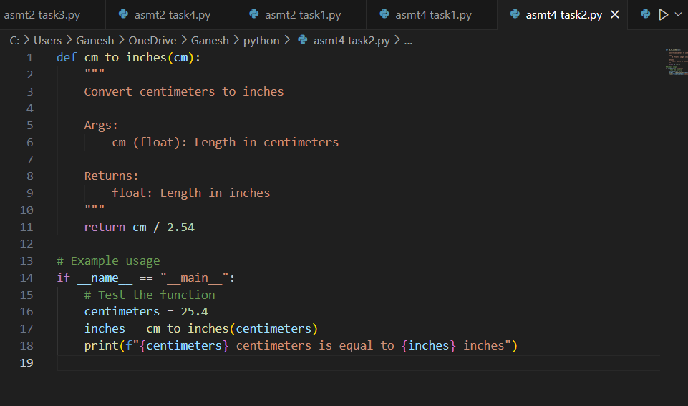

Expected Output: Function with correct conversion logic
Practical Output:

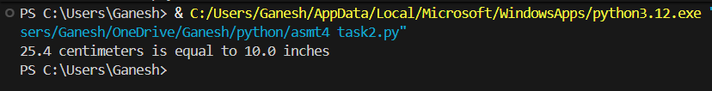

Task – 3
Description: One-shot: Few-shot: Provide 2–3 examples to generate a function that formats full names as “Last, First”.
Prompt: search for a few-shot prompt examples that show how to generate a function that formats full names as "Last, First"

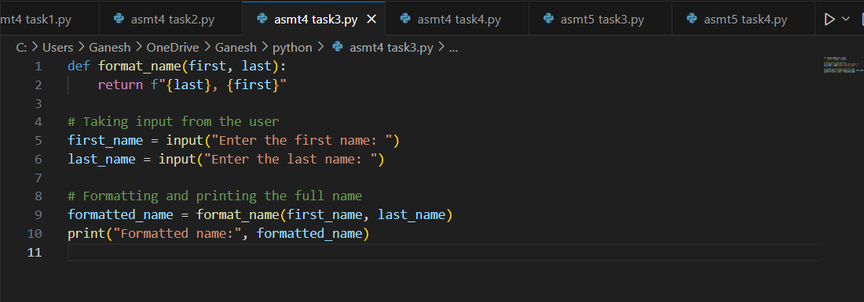
Expected Output: Well-structured function respecting the examples
Practical Output:

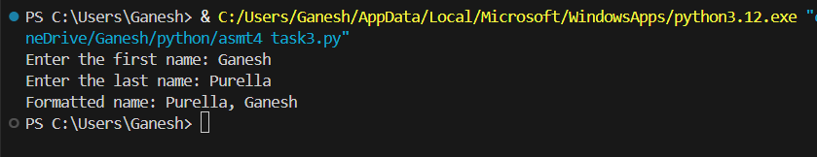

Task – 4
Description: Compare zero-shot and few-shot prompts for writing a function that counts the number of vowels in a string.
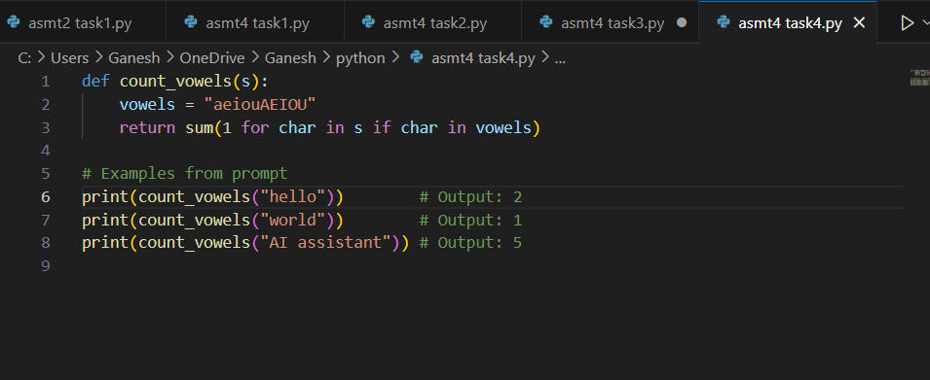

Expected Output: Functional output and comparative reflection
Practical Output:

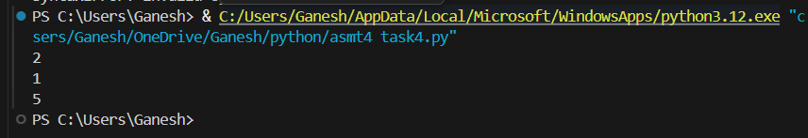

Task – 5
Description: Use few-shot prompting to generate a function that reads a .txt file and returns the number of lines

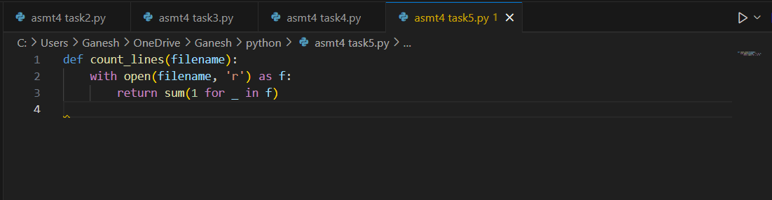

Expected Output: Working file-processing function with AI-guided logic
Practical Output:

